MELFA RV-2A/RV-3AJ Robot RELEASE
Two improved models of the existing RV-E robots are to be released in the UK from Jan 2003.

SAP Code model name replaces Description
a) 142185 RV-2A RV-E2 6 axes, 2kg payload robot & controller
b) 142824 RV-3AJ RV-E3J 5 axes, 3kg payload robot & controller

These are sold at exactly the same price as their RV-E equivalents. (e.g. RV-2A ->RV-E2)
Delivery Lead times are expected to be around 12 weeks.
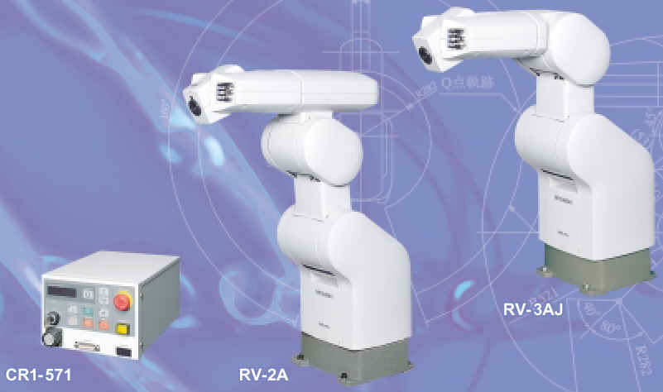
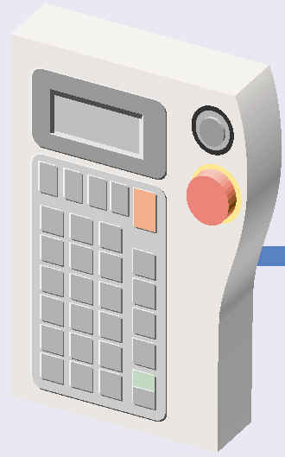
The RV-2A, RV-3AJ robots use the same CR1-571 controller as used by the RP-1AH / RP-3AH / RP-5AH “Cappuccino” parallel arm mini robot. Hence they will use the same MELFABASIC IV instructions as per other models of MELFA RV-A robot range as well as the option of using the simple to use, standard Movemaster Language utilised by the their predecessor RV-E series.

Improved features of Mitsubishi RV-2A / RV-3AJ robots :
- 64bit multi-tasking high performance CR1 controller .
- Orthogonal Compliance “soft” arm capability.
- Absolute encoders reduce maintenance and improve cycle time by 30%.
- Easy “Direct mode” control with OCX development on PC as the host controller.
- Conveyor-tracking option module available.
- Easy built-in RS422 and RS232C comms or expand with Ethernet or CCLINK to vision camera and other control devices.
- Easy SSCNET expansion to control further 8axes as base linear XY track or as XY linear track for worktable.

Key points when replacing RV-E series equivalents:
- The same mechanical arm as the RV-E2 is used in the RV-2A and similarly for RV-3AJ using the arm of the RV-E3J. Hence, they become direct replacements with no change required in the geometry design when replacing their RV-E counterparts.
- Since the encoders have improved, only RV-A arms will work with RV-A controllers and only RV-E arms will work with RV-E controllers (i.e. cannot mix RV-E arm will RV-A controllers).
- 95% of the existing code written in Movemaster Language can be directly used in the RV-A controllers. There may be some minor adjustments required due to the extra flexibility made available with these robots. Please see RV-A Movemaster datasheet for further details.
- The CR1 controller used in these robots are only about half the physical size of the RV-E equivalents and has a wide power supply tolerance range of AC207v to 253 VAC 1-phase (110v AC mode operation possible at reduced speed scenarios).

Teach Pendant and programming software:
- The RV-2A/ 3AJ uses the same R28TB teach pendant as with all RV-A series robots.
- COSIROP v1.7 onwards supports RV-2A, RV-3AJ robots.
- COSIMIR compatible version is planned for mid 2003.
- MELFAENG vC1 onwards supports the RV-2A, RV-3AJ robots.

Compatibility with other products:
The RV-2A, RV-3AJ robots use the CR1 robot controller which will use the same option interfaces as the other RV-A series of robots, example RV-2AJ, RV-4A etc..

Further information :
- RV-2A/ RV-3AJ brochure with a summary of specifications and options is available.
(PDF file avail.) ref: BRO-RV-2A/3AJ, 3 page leaflet, L-174-1-C5706-A
- RV-2A/ RV-3AJ Standard Specifications Manual
(PDF avail.) ref: BFP-A8174-C

